West Street/Bailey Lane Aquifer Fields - Georgetown, MA

Nest Box Summary Report – 2015

Overview

The 2015 season was the 4th season for the nest box program at the West Street Aquifer Field (WSAF) that is located off West Street in the field behind the Georgetown Athletic Field, and the 3rd season for the Bailey Lane Aquifer Field (BLAF) situated off Bailey Lane in Georgetown, MA. The nest boxes provide nesting sites for Eastern Bluebirds (EABL) and Tree Swallows (TRES). There are 4 nest boxes in West Street location situated in the back field that is not used for soccer. In the Bailey Lane Aquifer there are an additional 2 nest boxes. Both sites are near the Parker River as well as extensive wetlands adjacent to the river, which are protected public land managed by the Georgetown Water Department. This area is attractive to Eastern Bluebirds as well as Tree Swallows that can be often observed flying over open water foraging for insects and other aerial plankton. Nest box data has been shared with the *NestWatch* Program of the Cornell Lab of Ornithology (CLO). By participating in this program, nest data was available to download as Excel spreadsheets that were most helpful for reviewing and organizing data.

Nest identification of these avian species is relatively straightforward. Tree Swallow eggs are approximately the same size as bluebird eggs but entirely white. In contrast, Eastern Bluebird eggs are a robin’s egg blue with no markings. The egg-size of each species is approximately 0.8 inches in length. The typical clutch size ranges from 3-5 eggs and 4-6 eggs for bluebirds and swallows, respectively. Both species build similar cup-shaped nests using dried grasses that are commonly found in the area of the nest. Tree Swallows characteristically line their nests with white feathers while Eastern Bluebirds construct sparsely lined nests.

Typically, bluebirds will not nest within 200-300 feet of another pair of bluebirds. On the other hand, swallows are more social and less restrictive regarding nesting separation and their breeding territory range. Surprisingly, bluebirds and swallows show little reluctance to nest near each other. A reason for this disparity could be that they exploit different foraging stratums. Bluebirds prefer foraging near or on the ground often swooping from a perch to seize prey, a strategy referred to as “hawking”. In contrast, swallows are aerial foragers gathering prey in flight often well above the ground. Both avian species feed predominantly on insects and other small invertebrates. Interestingly, the Tree Swallow is the only swallow breeding in North America that includes berries in its diet. Due their mixed diet, Tree Swallows are able to return earlier and migrate later from their breeding grounds than any other swallow in North America. Bluebirds also supplement their diet with berries especially during winter and do not migrate.

**Nest Box Monitoring**

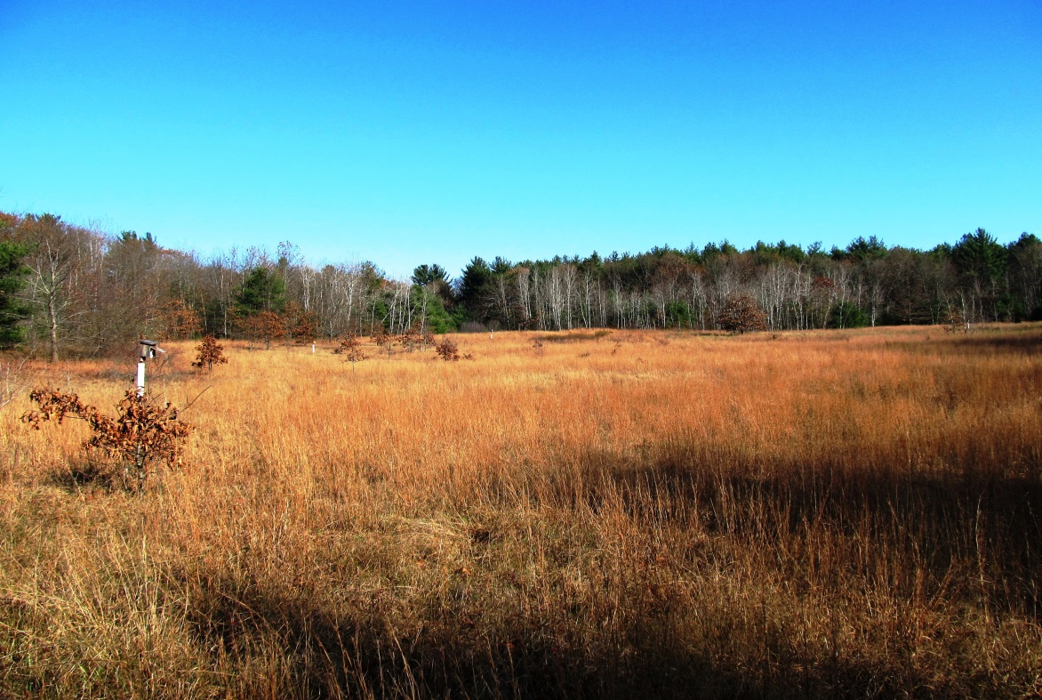Bluebirds may attempt their first nest early in April, while swallows tend to delay nesting until later in the month or even May, and have finished their nesting activity by July. Both April and May can present cold and wet weather with limited food opportunities making nesting success challenging. The Tree Swallow is single brooded while the Eastern Bluebird may have 2 or 3 broods per season. In the West Street field in 2015 the first clutch of bluebird eggs and swallow eggs were observed with estimated first-egg-dates of April 26th and May 11th, respectively. As was the case in 2014, only swallows nested in the Bailey Lane field, and the estimated first-egg-date was May 10th. The following photo, taken during breeding season, shows a nest box in the West Street field. The NestWatch *Protocol for Monitoring Nests* (Appendix A) was utilized as a guide for monitoring nest boxes. A *Trouble-Shooting Guide for Nest Box Landlords* is found in Appendix B. This guide is helpful for determining the cause of nest predation. For instance, under the first column of this guide (***what you might find***) you will notice in the 1st block down, ***eggs or*** ***nestlings missing, nest in tacked***. Moving across to column 2 (1st block down), you will discover that the possible cause of this event could be due to snake, rodent, House Wren predation. In the third column the guide suggests to ***install a predator guard or baffle to the box pole***.

Figure 1 West Street Field with Nest Box

Table 1 highlights the combined nest box data from 2012 – 2015 for WSAF and BLAF, including the total number of nest attempts and the number of attempts that produced at least one fledgling. Also included in the table are the total number of eggs, hatchlings and fledglings produced. A nest attempt is any nest with at least one egg present, and ends each time the parents begin a new clutch or once the nestlings fledges or nest fails. During 2015 bluebirds only nested in the West Street site, producing a total of 10 eggs and 10 bluebird fledglings. There were 11/13 eggs and 4/9 swallow fledglings produced in the West Street and Bailey Lane sites, respectively. In total there were 10/23 eggs and 10/13 fledglings of bluebirds and swallows, respectively.

## Table 1. Combined Nest Box Data at WSAF from 2012-2015

|  |  |  |  |  |  |  |  |
| --- | --- | --- | --- | --- | --- | --- | --- |
| **Season** | **Species** | **Total # Nest Attempts** | **First-Egg –Date of Season** | **Total # of Eggs** | **Total # of Hatchling** | **Total # of Fledgling** | **Nest Attempts with 1 or more Fledglings** |
| 2015 | EABL | 2 | 4/26/2015 | 10 | 10 | 10 | 2 |
| TRES | 4 | 5/10/2015 | 23 | 18 | 13 | 4 |
| 2014 | EABL | 2 | 04/29/2014 | 9 | 9 | 9 | 2 |
| TRES | 5 | 05/11/2014 | 28 | 24 | 23 | 5 |
| 2013 | EABL | 2 | 04/23/2013 | 9 | 7 | 7 | 2 |
| TRES | 3 | 05/11/2013 | 18 | 16 | 13 | 3 |
| 2012 | EABL | 1 | 04/25/2012 | 5 | 5 | 5 | 1 |
| TRES | 1 | 05/10/2012 | 6 | 2 | 2 | 1 |

In Table 2 additional reproductive data is presented for 2012 - 2015, namely the average number of eggs, hatchlings and fledglings per nest attempt. There was an average number of 5.0 and 5.75 bluebird and swallow eggs per nest attempt. The average number of eggs per nest was within the expected range of 3-5 and 4-6 eggs for bluebirds and swallows, respectively. All of the bluebird eggs successfully hatched and fledged averaging 5.0 fledglings per nest attempt. In comparison, 78% of the swallow eggs hatched with a fledge rate of only 56%, thus averaging 3.25 fledglings per nest attempt. The extended cold and wet weather in late May was a significant factor for the lower swallow nest productivity.

Paper wasps continued to be a problem at both sites, where wasps frequently constructed their nests inside nest boxes. Fortunately, once bluebirds and swallows have built a nest, they will readily evict these intruders but are less likely to accept a box already occupied by wasps. When a wasp nest is discovered inside a nest box, it is removed wearing a leather glove and with the aid of a paint scrapper.

**Table 2. Combined Reproductive Data at WSAF and BLAF from 2012–2015**

|  |  |  |  |  |
| --- | --- | --- | --- | --- |
| **Season** | **Species** | **Average # eggs per nest Attempt** | **Average #Hatchlings per nest Attempt** | **Average #Fledglings**  **per nest Attempt** |
| 2015 | EABL | 5.0 | 5.0 | 5.0 |
| TRES | 5.75 | 4.5 | 3.25 |
| 2014 | EABL | 4.5 | 4.5 | 4.5 |
| TRES | 5.6 | 4.8 | 4.6 |
| 2013 | EABL | 4.5 | 3.5 | 3.5 |
| TRES | 6.0 | 5.3 | 4.3 |
| 2012 | EABL | 5.0 | 5.0 | 5.0 |
| TRES | 6.0 | 2.0 | 2.0 |

**Recommendations**

The following recommendations should be considered:

1. The recent MAS report, *The State of the Birds*, indicates that that many of our obligate grassland birds such as the American Kestrel, Upland Sandpiper, Savanna Sparrow, Grasshopper Sparrow, Vesper Sparrow and Eastern Meadowlark, are exhibiting significant downward population trends. The occurrence of kestrels and meadowlarks nesting near or in the field should be documented and MAS alerted. In the case of Vesper and Grasshopper Sparrows, the Natural Heritage and Endangered Species Program (NHESP) needs to be notified as well.
2. Nest box inspection prior to the breeding season should be conducted to ensure old nesting material has been removed and the boxes are clean and as weather-tight as possible. Caulking cracks and spaces that have developed due to weathering and aging will help minimize weather-related fatalities. Predator guards must be maintained to deter mice, snakes and raccoons. Wasp management inside unoccupied boxes will encourage avian species to nest.
3. Unfortunately, nest boxes are also appealing to the House Wren (HOWR), which is not an obligate cavity nester. The male wren can be a menace to other species nesting in nearby nest boxes by pecking holes in their eggs. In order to minimize this mischief, nest boxes should be kept as far away as possible from shrubs and thickets, preferred wren habitat, unless the boxes are specifically meant for their use. For this reason, last October, nest boxes WS1, WS2 and WS4 at the West Street site were relocated further from the edge of the field, hopefully, discouraging nesting by wrens.

**Summary**

Early last century bird watchers noticed that the numbers of their beloved bluebird were diminishing. Conservationists noted that bluebird habitat was disappearing and the number of natural nest cavities was becoming ever scarcer. The Bluebird was also now competing for nest cavities with the House Sparrow and Starling that had been introduced from Europe. Bluebird conservationists like Lawrence Zeleny, implemented conservation measures to reverse this trend. Throughout the eastern part of the country, concerned conservationists and bluebird enthusiasts began erecting nest boxes specifically designed to attract bluebirds and coincidently Tree Swallows**.** These boxes are often even used by bluebirds to conserve body heat on cold nights in the winter. A series of strategically placed nest boxes became known as bluebird trails. As revealed in *The State of the Birds* published by the MAS in 2013, the Bluebird has successfully rebounded and is now experiencing an increasing population trend. The news is somewhat positive for the Tree Swallow as well. Unfortunately, the report for many field birds is not so optimistic, such as the American Kestrel and Bobolink and several native sparrows.

In 2015 there were a combined total of 10 Eastern Bluebirds and 13 Tree Swallows that fledged from WSAF and BLAF nest boxes. All 10 bluebird eggs successively hatched and the hatchlings were equally successful resulting in 10 fledglings, averaging 5.0 fledglings per nest attempt. This season was the most productive year for bluebirds. In comparison, only 74% of swallow eggs hatched and 78% of the nestlings fledged with an overall nest productively of 56% or 3.25 fledglings per nest attempt. There were no bluebird nest attempts in either 2014 or 2015 in the BLAF. The following graph presents the number of bluebirds and swallows that fledged each year from 2012 through 2015. In 2012 there were only nest boxes (4) in the WSAF. The following year, 2 nest boxes were placed in the BLAF. The blue and maroon columns represent the number of bluebirds and swallows that fledged, respectively.

***Some Interesting Nest Box Facts,*** which concisely presents relevant nest box facts, is fond on page 7.

**Resource Information**

* Cornell Lab of Ornithology Program.

<http://watch.birds.cornell.edu/nest/home/index>

Bird Guide … <http://www.allaboutbirds.org/guide/search>

NestWatch … <http://nestwatch.org/>

NestWatch Digest 2015 … <http://nestwatch.org/connect/news/our-year-end-report-is-here/>

* Salias … <http://www.sialis.org/index.html>
* How to Create and Manage Tree Swallow Nest Boxes <http://www.treeswallowprojects.com/index.html>
* Ehrlich P.R., Dobkin D.S., Wheye D. 1988. *The Birder’s Handbook – a Field Guide to the natural History of North American Birds*. Fireside Book Published by Simon & Schuster Inc.
* Massachusetts Bluebird Association … <http://www.massbluebird.org/>
* Mass Audubon Society, 2013. *The State of the Bird.* <http://www.massaudubon.org/our-conservation-work/wildlife-research-conservation/statewide-bird-monitoring/state-of-the-birds>
* Mass Audubon Society. *Birds to Watch Program*, American Kestrel. <http://www.massaudubon.org/Birds_and_Birding/birdstowatch/kestrels/howyoucanhelp.php>
* New England Nature Bluebird Information … <http://www.nenature.com/EasternBluebird.htm>
* North America Bluebird Society … <http://www.nabluebirdsociety.org/>
* Peterson R.T., 1980 4th Edition. Eastern Birds, Peterson Field Guides. Houghton Mifflin Company, Boston
* Sibley D.A. 2003 First Edition. The Sibley Field Guide to Birds of Eastern North America. Alfred A. Knopf, New York.
* Sibley D.A. 2009. The Sibley Guide to Bird life & Behavior / illustrated by David Allen Sibley ; edited by Chris Elphick, John B. Dunning, Jr., David Allen Sibley. Publisher: Alfred A. Knopf, New York
* Zeleny L. 1978. *The Bluebird*. Indiana University Press

**Some Interesting Nest Box Facts**

**Eastern Bluebird**: Sialia sialis - 7 inches in length

**Voice:** Call note – chur-wi or tru-ly Song – 3 or 4 soft gurgling notes

**Favored Habitat**: Open country with scattered trees, farms, along roadsides.

**Nest:** Cavity; either natural tree hole, or bird box. Built by female; a loose cup of grasses, weed stems, pine needles, twigs, occasionally with hair or feathers. Built in 1-6 days.

**Egg laying:** 5-7 days (sometimes more) – one egg per day, with at least one day in between eggs.

**Eggs:** 3-6, usually 4-5; pale blue, occasionally white, unmarked; 0.8”

**Incubation period:** 12-14 days

**Nesting Schedule** (after hatching):

Day 1: Bright coral-pink skin, eyes sealed, down in sparse tufts.

Day 2 – 4: Wings, head and spine look bluish due to developing feathers under skin.

Day 5 –7: Feather sheaths begin to emerge on wings. Eyes still closed.

Day 8 – 11: Eyes open! Feathers sheathes continue to grow.

Day 11 – 12: Feathers of wing and tail reveal cobalt blue in males, duller gray-blue in females. Females also show white edging on outer tail feathers.

Day 13: CUT OFF DATE FOR BOX CHECKS! Fully feathered young become increasingly active, and may fledge prematurely if box is opened.

Day 14 – 22: Fledging occurs and first flights.

Young remain in cover while parents bring food.

Day 30-on: Fledglings feed on their own.

2-3 Broods per season

**For comparison**:

**Tree Swallow**

**Nest:** Somewhat similar to bluebird but mostly grasses and lined with feathers.

**Eggs:** 4-6, pure white without gloss; Incubation: 13-16 days; 1 brood

**House Sparrow**

**Nest:** Huge ball of grass, weeds, trash with opening on side; very messy; lined with feathers, hair or string.

**Eggs:** 3-7, white, greenish white; spotted with grays and browns. Incubation: 12-13 days; 2-3 broods

**Online Resources:**

New England Nature Bluebird Information … <http://www.nenature.com/EasternBluebird.htm>

North America Bluebird Society … <http://www.nabluebirdsociety.org/>

How to Manage Tree Swallow Nest Boxes … <http://www.treeswallowprojects.com/index.html>

**Appendix A … NestWatch Protocol for Monitoring Nests**

*We recommend a* ***maximum of 8−10 visits spread out*** *over the course of the nesting attempt. As a general rule, if you* ***check*** *nests* ***every 4-5 days****, you will be closely following the protocol below.*

**Nest Building (1 visit, if possible)**

If you are fortunate enough to find an active nest **while it is being built**, be sure to record the status of the nest on the **datasheet**.

**Egg Laying Period (1 or 2 visits)**

Make at least **one** visit **during egg laying**, preferably in the **afternoon**. If you find a **nest with eggs, go back three days later** to determine if the number of eggs has changed. This will help determine first egg date and the egg laying rate. For songbirds, the typical laying period lasts between three and eight days, with eggs laid one per day, usually early in the morning.

Knowing the date the first egg was laid is critically important and easy to determine if you can visit during the egg laying period. For example, if two eggs are in the nest on May 10 and four eggs on May 13, then counting backward one egg per day, we know the first egg was laid on May 9. The second egg was laid on May 10, the third on May 11, and the fourth and last egg on May 12.

Whenever possible during nest checks, wait for the female to leave the nest rather than flushing her off. **Record the number of eggs,** if known, along with any **adult activity** you observed, on your datasheet.

**Incubation Period (2 visits)**

Make **two visits, preferably in the afternoon**. We suggest one visit at the middle and one at the end of incubation to determine complete clutch size and whether eggs have been lost. Most songbirds begin incubating the day before the last egg is laid and will typically incubate eggs for 11 to 14 days. **Record the number of eggs,** if known, along with any **adult activity** you observed, on your datasheet.

**Hatching Period (1 visit)**

Visit **once at or just after hatching** to pinpoint the timing of hatching and determine the number of hatched eggs. Most songbird eggs hatch within 24−48 hours of each other. If you see adults carrying food, this is a good sign that eggs have hatched. Check the nest contents and **record the number of eggs, observed adult activity, and status of young** on your datasheet.

**Nestling Period (2 visits)**

Visit **once when young** are thought to be **between five and seven days old** to determine their development and survivorship. Visit **again three or four days later** to get an estimate of the number of young likely to fledge.

Do not open nest boxes or disturb nests with fully feathered young, as this can cause premature fledging. Once the young are fully feathered, you can check the nest from a distance with binoculars to determine if the parents are still actively feeding the young.

Typical songbird nestling periods last approximately two to three weeks. **Record your observations for number of eggs (if any), observed adult activity, and status of the** young on your datasheet.

**Appendix A continued**

**Fledging Period (1 visit)**

Visit **once to determine success or failure of nests**. Do not open nest boxes or disturb nests that have fully feathered young, as this can cause premature fledging. Most songbirds fledge within one to two days of each other.

Check the nest from a distance and look around for the adults. If they go to the nest carrying food, the young have not yet fledged. If they go somewhere else, it is likely they are feeding the young in nearby vegetation.

If you are certain the young have fledged, check the nest and make sure it looks intact, i.e., flattened, and in some cases covered in fecal matter. If it appears disheveled or depredated, describe what you see on your data sheet and look for any signs of the nestlings (feathers, body parts, bones) in the area surrounding the nest site.

If you suspect predation has occurred, try to determine the predator by looking around the nest site for clues. If adults are still present, continue monitoring their activity as they may try to nest again. **Record the outcome, estimated number of fledged young, and additional comments** for the nest attempt on the datasheet.

**Post Fledging Period (1 visit)**

Visit the nest **one last time** after you are certain that all the young have fledged to **determine if any unhatched eggs or dead young remain**. Record additional comments for the nest attempt on the datasheet.

Stay alert—birds that raise more than one brood per season may nest again nearby. If possible, try to keep monitoring nests to the end of the season, July or August.  If you find another active nest, please follow the same protocol. Use a separate datasheet for each new nest attempt

**Appendix B …Trouble-shooting Guide**